Setting up a VoIP solution with SIP

Step 1 - Download and Install Brekeke SIP Server
- Download the Brekeke SIP Server installer from the shared drive.
After successfully installing the product, a Brekeke SIP Server icon will appear on your PC's desktop.
- Activate Brekeke SIP Server Start the Brekeke SIP Server by double-clicking the [Brekeke SIP Server] icon from your PC desktop. Activate Brekeke SIP Server with product ID. Use the following: BR96A5A100001115
- Login. Enter "sa" in both the [User ID] and [Password] fields from the Brekeke SIP Server Admintool screen. Start Brekeke SIP Server. The Status field should indicate that the Brekeke SIP Server is Active.

Step 2 - Setting Up SIP Server for User Authentication
The authentication for REGISTER and INVITE is enabled by default on Brekeke SIP Server, which is set at Brekeke SIP Server > [Configuration] > [SIP] > [Authentication]. To register SIP UA with Brekeke SIP Server authentication on, create [User Authentication] account for each SIP UA is needed. Do the following to set up authentication accounts at Brekeke SIP Server:
- Choose Brekeke SIP Server >[User Authentication] >[New User], and set.
  - [User]: UA UserName.
  - [Password]: SomePassword.
  - [(Confirm)]: SamePassword.
  - [Name]: Description to remind whose auth account it is.
  - Click [Add].
  - To make sure the user authentication information is added for this user, check from [View Users].
- In this example, we will create Authentication accounts for two X-Lite Soft Phones. In the following setup, the authentication user IDs will be the same as the phone numbers (SIP user ID). It is required by default settings of Brekeke SIP Server authentication.
  - X-Lite 1 User Authentication account at Brekeke SIP Server:
    - [User]: 111
    - [Password]: 1234
    - [(Confirm)]: 1234
    - [Name]: XLite1
  - X-Lite 2 User Authentication account at Brekeke SIP Server:
    - [User]: 999
    - [Password]: 1234
    - [(Confirm)]: 1234
    - [Name]: XLite2

Step 3 - Setting up X-Lite as a SIP UA
- Set up X-Lite as a SIP UA on your PC:
  - Start X-Lite from your PC by choosing Start->All Programs->X-Lite
  - Click on Softphone – Account Settings
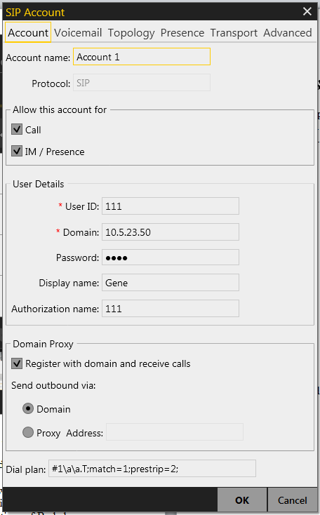
Add your account settings as above. Repeat the steps for the other User Agents.
- Verify that X-Lite has successfully registered with Brekeke SIP Server from [Registered Clients] tab. You should see that the X-Lite is registered as User 111
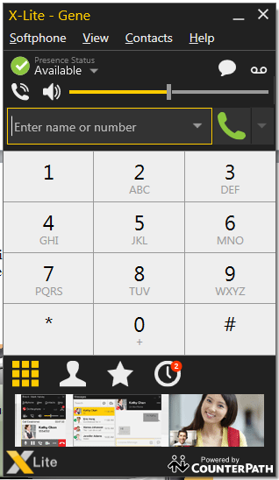
X-Lite SIP Softphone

Step 5 - Making VoIP Calls
To make a call from X-Lite, follow these steps:
- Enter 999 and click on [Dial] button
- To hang up, click on [hang up] button

Step 6 – Configuring Linksys SPA941
- Press the menu button on the phone and navigate to the Network
- Record the IP address of the phone
- Enter the IP address into a browser and you will see the Linksys configuration GUI.

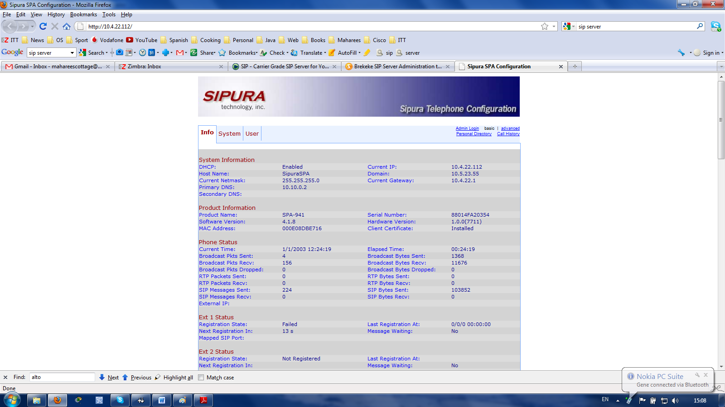
Click on admin. Select System and change Domain to the IP address of the SIP server.
Click on Phone. Change the Line Key 1 Short Name to 555
Click on Ext1. Change the Proxy setting to the IP address of the SIP server. Change the Display Name to any identifier. Change the User ID and Auth ID to 555. Change the password to 1234
Your phone shoud reboot with the new settings applied

Step 6 – Capturing and viewing SIP commands
- Download and install Wireshark from Xythos.
- Create a new filter to capture SIP traffic.
- Start capture.
- Get one device to call the other.
- View and explain the packets captured. (Should look something like below)
- Note and explain where the SDP information is exchanged.

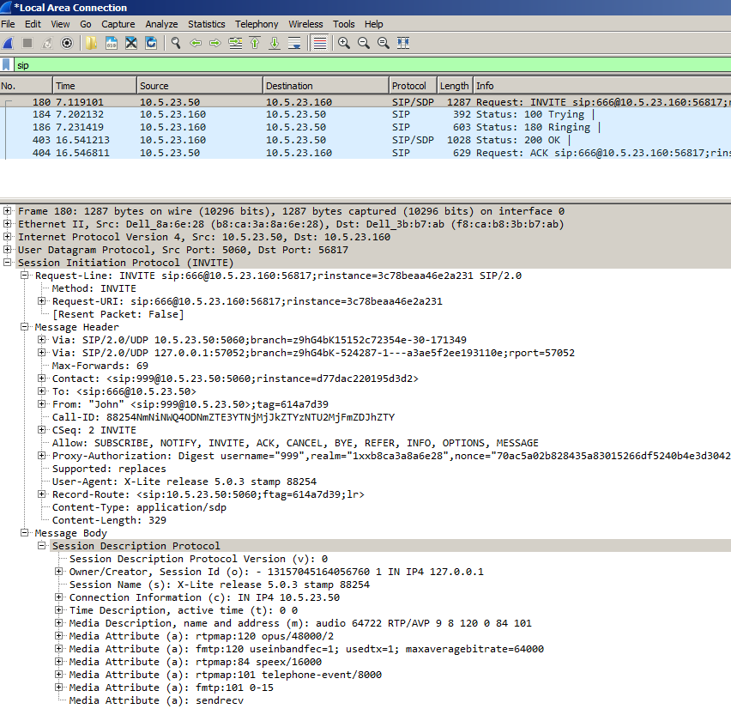
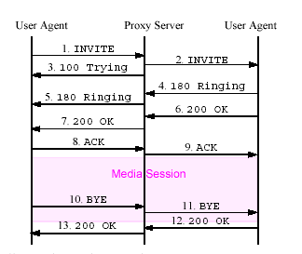

RTP Packet Size
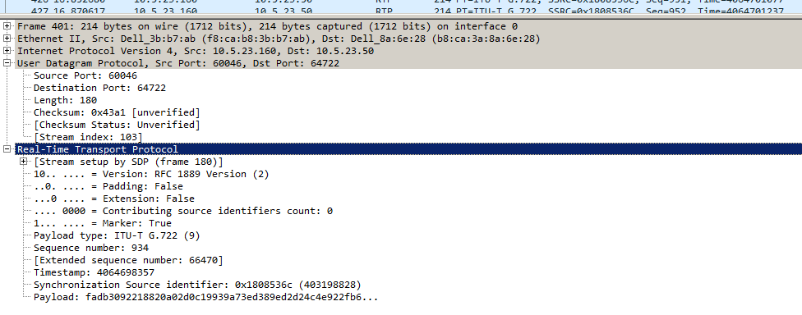
We can see that the RTP packets are 214 bytes in size. The codec being used is a 64kbps G.722. The packet interval is 20ms. This means that there is 64000/50 bits of voice sent every 20ms, i.e. 160 bytes of voice. The headers added to the encoded voice are as follows:
RTP = 12 bytes
UDP = 8 bytes
IP = 20 bytes
Ethernet = 14 bytes (doesn’t include CRC)
Total packet size = 160+12+8+20+14 = 214 bytes.

